**STANDARD OPERATING PROCEDURE**

**Dumping of OB/spoil in dumps and**

**Stacking of Ore in Stockpiles & re-handling of ore**



**ODISHA MINING CORPORATION LTD.**

**KODINGAMALI BAUXITE MINE**

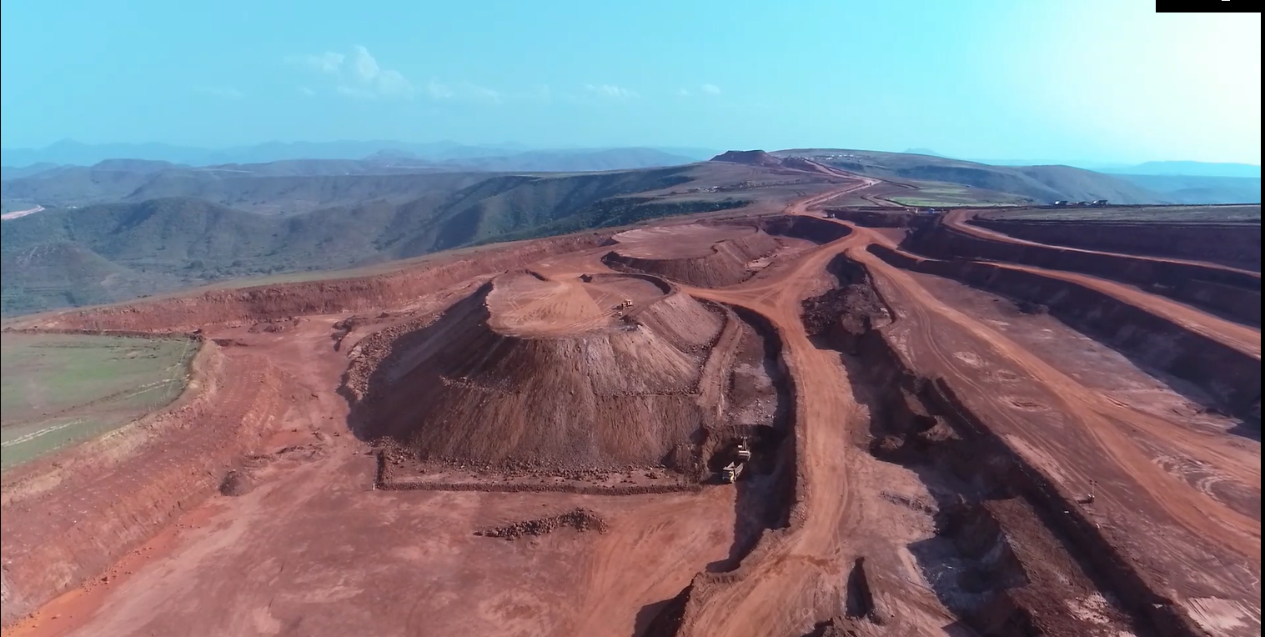

**Authorized By:**

### SOP for Dumping of OB/spoil in dumps and

### Stacking of Ore in Stockpiles & re-handling of ore

### This SOP for Dumping of OB/spoil in dumps; Stacking of Ore in Stockpiles; and re-handling ore from such Stockpiles establishes a safe working environment and system of work, also defining competencies, in order to establish a safe and secure OB/Spoil dump & Ore-stockpile profiles, and also lays down system of work for dumping of OB/spoil, stacking of ore, and re-handling of ore there-from, so that the dumps and stockpiles carry minimal risk of failure and potential for any injury to persons and/or damage to equipment is minimized during dumping, stacking and re-handling operations. The SOP also lays down procedures for inspection and monitoring of dump & stack-slope profiles not only to ensure that they conform to their design-geometry, but also to detect timely any signs of potential failures.

### The guidelines of the SOP shall be implemented along with stipulations of the Metalliferous Mines Regulations, recommendations of scientific studies carried out, if any, and of the permissions granted by DGMS, as well as directives/circulars/ notifications issued by DGMS from time to time.

### A Dump & Dump-slope Design Parameters & their monitoring:

1. Spoil/OB removed from the mine shall be dumped at places belong­ing to the mine & duly approved by the manager in writing.
   1. The site chosen for dumping of spoil/OB shall be such that no OB/Spoil is dumped beneath or close to power transmission or telephone lines, also ensuring that the toe of OB dumps does not get extended within 100m of any public works, public road, power/transmission/telephone lines and permanent structures not belonging to M/s OMC.
   2. A suitable fence shall be erected between the toe of the spoil bank and such public works or road or building or structure not belonging to M/s OMC so as to prevent unauthorized persons from approaching the toe of any OB dump.

**Responsibility: RM, Manager, Safety Officer**

1. No top soil, clay, alluvium, etc., or material of low load bearing capacity shall be dumped on the floor of any OB dump as to form the base of the dump, or at any intermediate levels of OB dumps.
   1. Top soil shall be stacked separately, and shall be used for capping the OB dumps once they have reached their ultimate/permissible height, as to enable forestation/restoration of the environment.
   2. The slope of the spoil banks shall be the natural angle of repose of the material being deposited or shall not exceed 370 from horizontal.
   3. The toe of the dump shall not be retained by any artificial means as to increase the slope of spoil bank excess of its natural angle of repose.

**Responsibility: Manager, Safety Officer, Asstt. Managers**

1. **In iron-ore and bauxite mines**, dumping of spoil/OB shall be so done that spoil-banks are benched at intervals not exceeding 30m in height or in accordance with the permission granted by DGMS, whichever is less. The width of such benches shall not be less than the height of the bench and the general slope of the spoil bank shall not exceed 1 vertical to 1.5 horizontal.
   1. Slopes may as well be benched at lesser intervals in the interest of safety if space available for dumping so permits.
   2. The height of any spoil bank/OB dump shall not exceed 60m unless a scientific study on dump-stability has been carried out, and permission to the effect has been obtained from DGMS in line with recommendations of the scientific study.

**Responsibility: Manager, Safety Officer, Asstt. Managers**

1. **In chrome ore mines**, dumping of spoil/OB shall be so done that spoil-banks are benched in accordance with the recommendations of scientific study carried out by an agency having expertise in this regard and in accordance to the stipulations of the permission granted by DGMS.
   1. The width of such benches shall not be less than the height of the bench, and the general slope of the spoil bank shall not exceed 1 vertical to 1.5 horizontal.
   2. The height of spoil bank/OB dump shall also not exceed the height as recommended by the scientific study.

*[The most recent study conducted by CIMFR vide their Report dated January 2021, stipulates that dump slope shall be benched at intervals not exceeding 20m, bench width shall not be less than 20m and bench slope shall not exceed angle of repose or 370. Maximum height of the dump shall not exceed 150m.]*

**Responsibility: Manager, Safety Officer, Asstt. Managers**

1. During dumping of OB and maintenance of the dump or its benches, it shall be ensured that no water is allowed to accumulate at the dump-top or any of the benches already formed. Natural gravitational drainage shall be provided by sloping the dump-top and the intermediate benches, as well as the haul road leading to dump-top, and collector drains to collect and drain out the rain-water and prevent its seepage into the dump shall further be provided.
   1. It shall be ensured that the collector drains are kept maintained free of debris and loose material that may slide in.
   2. The top as well as benches of all active as well as old dumps shall be regularly inspected at intervals fixed by the Manager, more particularly during rainy season and post-monsoon, by a person not below the rank of Mine Foreman and any deformation or formation of tensile cracks shall be brought to the notice of the Manager forthwith.
   3. If any cracks are so observed, they shall be filled with sandy material immediately so as to check the entry of water in the dump mass.
   4. A record of such inspections shall be maintained in a bound paged book.

**Responsibility: Manager, SO, Asstt. Managers, Foremen & Mining Mates**

6 The Dump-design & dump-slope profile parameters of dumps exceeding 60 metres in height shall be monitored by suitable survey instruments to ensure their accurate and up-to-date geometry.

6.1 Frequency of such measurement shall be fixed by the Manager and may be increased during monsoon and post-monsoon periods when dump-slopes are more likely to fail because of rain, which may lower cohesion of the dump-material mass.

6.2 A record of such measurement shall be kept maintained in the bound paged book kept for the purpose, which shall be signed by the surveyor entrusted with such responsibility and shall be counter-signed by the Manager.

6.3 Persons engaged in inspection of the dumps and their benches, and those engaged in monitoring of dump-geometry shall be imparted job-specific training before being deployed for the purpose.

**Responsibility: Manager, SO, Surveyors & their Assistants**

**B Dumping of OB/Spoil in OB dumps**

1. OB/Spoil removal from the mine and its dumping in OB dump-yards shall be placed under overall charge of an Assistant Manager, who shall ensure during dumping of spoil/OB that dump-design and dump-slope parameters are kept maintained in accordance of this SOP.

* 1. Dumping of OB/spoil in OB dumps and regulation of movement of tipper-trucks on dumping platform in each of the working shifts shall be carried out under personal supervision of a competent person (Mine Foreman or Mining Mate).
  2. Before commencement of dumping operations and also at regular intervals during his shift, the competent person shall inspect the dumping platforms/dump-tops, wherefrom dumping of OB/spoil is carried on, for any signs of sinking and/ or formation of tensile cracks.
  3. If signs of any formation of tensile cracks or sinking of dumping surface are observed, dumping operations in the said area will be stopped immediately and brought to the notice of the Assistant Manager/Manager forthwith. Dumping in the said area shall resume only after the matter has been investigated, corrective actions have been taken and formal approval is accorded by the Manager.
  4. The competent person shall regulate the movement of dumpers/tipper-trucks in an orderly manner so that there is no crowding at the dumping platform, and shall also ensure that dumpers/tipper-trucks dump OB/spoil at the designated places and in the manner prescribed.
  5. Only top dumping of OB/spoil will be done to prevent dumpers/tipper-trucks rolling back & down the dump-slope. Dumped OB/spoil material shall be regularly pushed down the dump slope by dozer.
  6. Where edge dumping of spoil/OB becomes unavoidable, a berm or embankment shall be provided at the edge of the dumping platform whose width at top shall not be less than 1 meter and its height shall be not less than the diameter of the tyre of the largest dumper/tipper-truck engaged in dumping/stacking.
  7. Movement of the dumpers/tipper-trucks shall be regulated by the competent person standing on an elevated traffic island to prevent risk of him being run-over by the tipper-trucks. He shall not stand near the dump-edge or in the operational area of dumpers/tipper-trucks engaged in dumping of OB/spoil. Suitable code of signals by means of coloured flags or batons shall be framed and implemented for the purpose.

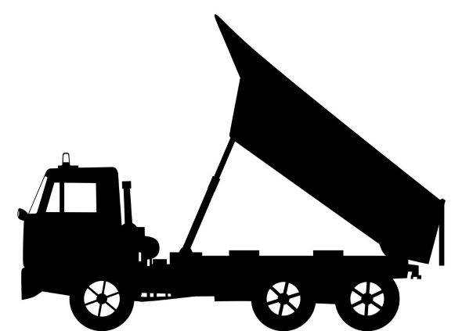

***For explanation purposes only***

**Dumping platform**

**Berm**

**Elevated platform/traffic island for competent person to regulate traffic**

**Edge Dumping** edge

**Dump-edge**

### C Stacking of Ore in Stockpiles and re-handling thereof:

1. All ore, including low-grade ore shall be stacked at places belong­ing to the mine and duly approved by the manager in writing.
   1. The sites chosen for stacking of different categories of ore, including low-grade ore shall be such that ore is not stacked beneath or close to power, transmission or telephone lines, also ensuring that the toe of the ore-stockpiles do not get extended within 100m of any public works, public road, power/transmission or telephone lines and permanent structures not belonging to M/s OMC.
   2. A suitable fence shall be erected between such public works or road or building or structure not belonging to M/s OMC and the toe of the stockpiles so as to prevent unauthorized persons from approaching it.
   3. The slope of stockpiles shall be the natural angle of repose of the ore being stacked and should not exceed 370 from horizontal.
   4. The toe of the stockpiles shall not be retained by artificial means as to increase their slope in excess of natural angle of repose of the ore being stacked.
   5. Stacking of ore including low-grade ore shall be done in a manner that stockpile slopes are benched in accordance with the stipulations, if any, of permission granted by DGMS or at intervals not exceeding 20m in height. The width of such benches shall not be less than the height of the bench.
   6. Stockpiles slopes may as well be benched at lesser intervals in the interest of safety if space requirements so permit.
   7. The height of stockpiles shall not exceed 40m.

**Responsibility: Manager, Safety Officer, Asstt. Managers**

1. During stacking of ore including low-grade ore and maintenance of stockpiles, it shall be ensured that no water is allowed to accumulate at any bench or at the top of stockpiles. Natural gravitational drainage shall be provided by sloping the stockpiles-top and the intermediate benches, if any, as well as the haul road leading to top of the stock-piles.
   1. Collector drains to collect and drain out the rain-water and prevent its seepage into the stockpile-mass may further be provided, and such drains shall be kept maintained free of debris and loose material that may slide in.
   2. The top of all active as well as old stockpiles and benches formed along their slopes shall be regularly inspected, more particularly during rainy season & post-monsoon, at intervals fixed by the Manager, by a person not below the rank of Mine Foreman and any deformation or formation of tensile cracks shall be brought to the notice of the Manager forthwith. They shall be filled with fines immediately so as to check the entry of water in the stockpile mass.

**Responsibility: Manager, SO, Asstt. Managers, Foremen & Mining Mates**

1. The operations connected with stacking of ore in each stockpile shall be placed under the charge of a competent person in each of the working shifts who shall personally supervise such operations.
   1. Re-handling operation for dispatch of ore from the mine (if carried out simultaneously along with stacking of ore) shall also be placed under the charge of a separate competent person.

10.2 Operations connected with stacking of ore received from mine and re-handling of ore from stockpile for dispatch shall be kept segregated, **and shall not be done simultaneously from the same place or vertically above/below each other**.

10.3 Before commencement of dumping of ore in stockpiles or re-handling of ore there-from, and also at regular intervals during the shift, the dumping and loading platforms/surfaces shall be inspected by the competent person for signs of sinking and/or formation of tensile cracks. If signs of any formation of tensile cracks are observed, dumping of ore or re-handling operations, as the case may be, shall be stopped immediately and the same shall be brought to the notice of the Manager forthwith. Dumping of ore or re-handling shall resume only after the matter has been investigated, corrective actions have been taken and formal approval is accorded by the Manager.

10.4 The competent person(s) shall regulate movement of dumpers/tipper-trucks engaged in stacking of ore or of buyers’ trucks engaged in dispatch or ore from the mine in an orderly manner so that there is no crowding during stacking of ore or re-handling of stockpile.

10.5 Movement of the dumpers/tipper-trucks or buyers’ trucks, as the case may be, shall be regulated by the competent person standing on an elevated traffic island to prevent risk of him being run-over by the tipper-trucks or buyers’ trucks. Suitable code of signals by means of coloured flags or batons shall be framed and implemented for the purpose.

10.6 Only top-dumping of ore shall be done to prevent dumpers/tipper-trucks rolling back & down the stock-pile slope. Dumped ore shall either be levelled or pushed down the stock-pile slope by dozer at regular intervals.

* 1. Stockpiles exceeding digging height of the loading equipment deployed for re-handling shall be re-handled **top-downwards** by forming artificial benches on the stack-slopes. Width of such benches shall be adequate as to permit safe operation of the equipment deployed for loading and transport of ore.

**Responsibility: Manager, SO, Asstt. Managers, Foremen & Mining Mates**

*******************************